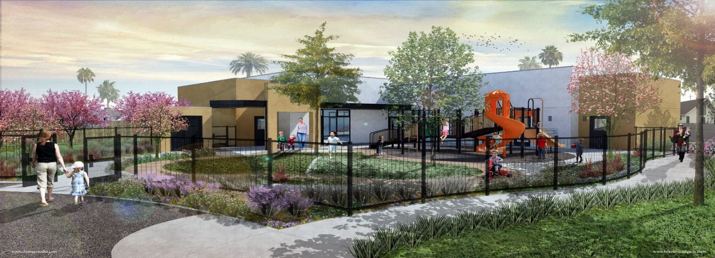
St. Charles Catholic Preschool
2021-2022 Tuition Fees

Annual Registration Fee: $300.00 per child
(Pay this non-refundable fee to reserve your child’s place)
Accepting applications for 3-yrs old (fully potty trained) to 5-yrs old
(It is a requirement that parents visit our preschool with their child prior to applying.)
Please note: The monthly tuition is NOT based on the school days in a particular month; it is based on the yearly tuition divided by 10 months.
Days (Part-Time) | Time | Yearly Tuition | Monthly Tuition
Tues/Thurs | 8:00 a.m. to 11:30 a.m. | $3,500.00 | $350.00 (Is Not offered yet )
Mon/Wed/Fri | 8:00 a.m. to 11:30 a.m. | $5,000.00 | $500.00
Monday-Friday | 8:00 a.m. to 11:30 a.m. | $5,750.00 | $575.00

Days (Full-Time) | Time | Yearly Tuition | Monthly Tuition
Tues/Thurs | 8:00 a.m. to 3:00 p.m. | $4,500.00 | $450.00 (Is Not offered yet)
Mon/Wed/Fri | 8:00 a.m. to 3:00 p.m. | $5,750.00 | $575.00
Monday-Friday | 8:00 a.m. to 3:00 p.m. | $6,500.00 | $650.00
Monday-Friday | 8:00 a.m. to 3:00 p.m. | $6,250.00 | $625.00 Peace officer or Military families
Days (1 hour Extra-Time) | Time | Yearly Tuition | Monthly Tuition
Monday-Friday | 7:00 a.m. to 3:00 p.m. | $7,750.00 | $775.00
Monday-Friday | 8:00 a.m. to 4:00 p.m. | $7,750.00 | $775.00
Monday-Friday | 7:00 a.m. to 3:00 p.m. | $7,500.00 | $750.00 Peace officer or Military families
Monday-Friday | 8:00 a.m. to 4:00 p.m. | $7,500.00 | $750.00 Peace officer or Military families
Days (2 hours Extra-Time) | Time | Yearly Tuition | Monthly Tuition
Monday-Friday | 7:00 a.m. to 4:00 p.m. | $8,750.00 | $875.00
Monday-Friday | 7:00 a.m. to 4:00 p.m. | $8,500.00 | $850.00 Peace officer or Military families
The Saint Charles Preschool Curriculum includes two days of Spanish language introduction per week, (Wednesdays & Thursdays.)
First tuition payment is due on the 5th day of each month, (First tuition payment needs to be paid prior to the first day of attendance). All tuition payments are paid through FACTS Tuition Management and will be deducted from your checking account. A $25.00 monthly tuition discount for Five days/Full Time schedule students (8:00 a.m. to 3:00 p.m.) will be applied for active military, and peace officers. Healthy snacks provided. Lunch IS NOT provided by our preschool. A healthy lunch must be brought from home. Lunch is at 11:30 a.m., for students whose schedule is full time.
Preschool Phone number: 1 (619) 423-0784

